Project Design Phase-II
Data Flow Diagram & User Stories

Date | 28 September 2026
Team ID | SWTID-2026-5471
Project Name | AI Study Buddy
Maximum Marks | 4 Marks

Data Flow Diagrams:
A Data Flow Diagram (DFD) is a traditional visual representation of the information flows within a system. A neat and clear DFD can depict the right amount of the system requirement graphically. It shows how data enters and leaves the system, what changes the information, and where data is stored.
Example: DFD Level 0 (Industry Standard)
Example:
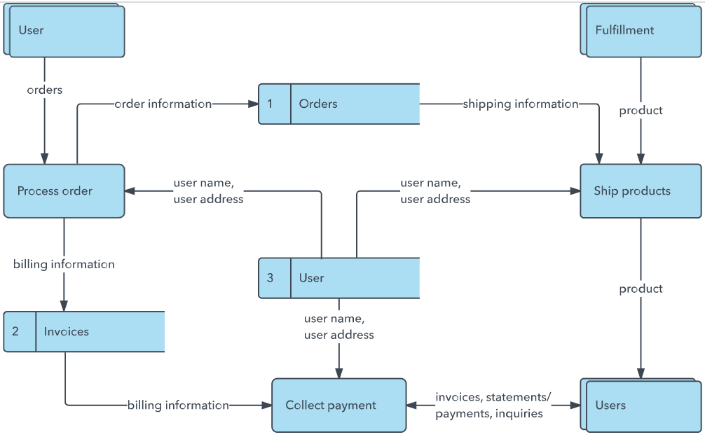


User Stories
Use the below template to list all the user stories for the product.
User Type | Functional Requirement (Epic) | User Story Number | User Story / Task | Acceptance criteria | Priority | Release
Student | User Registration | USN-1 | As a student, I can register using my name, email and password. | Account is created successfully and the student can access login. | High | Sprint-1
Student | User Login | USN-2 | As a student, I can log in using my email and password. | Valid credentials open the student dashboard. | High | Sprint-1
Student | AI Study Assistance | USN-3 | As a student, I can ask study questions and receive AI-based explanations. | A relevant AI response is returned for the submitted question. | High | Sprint-1
Student | Quiz & Practice | USN-4 | As a student, I can take AI-generated quizzes and practice questions. | Quiz questions are generated and results are displayed after submission. | High | Sprint-2
Student | Study Planning | USN-5 | As a student, I can create a personalized study plan. | A study plan is generated and displayed. | Medium | Sprint-2
 | Dashboard
Customer (Web user)
Customer Care Executive
Administrator

Project Team: Elakiya S (Team Leader), Boomika S, Deepa S, Devadharshini M, Dhanasri B
Project: AI Study Buddy

